**EXP 3: CREATE A VIRTUAL HARD DISK AND ALLOCATE THE STORAGE**

**USING VM WARE WORKSTATION**

**PROCEDURE:**

**STEP 1:**

**GOTO VM WARE WORKSTATION**

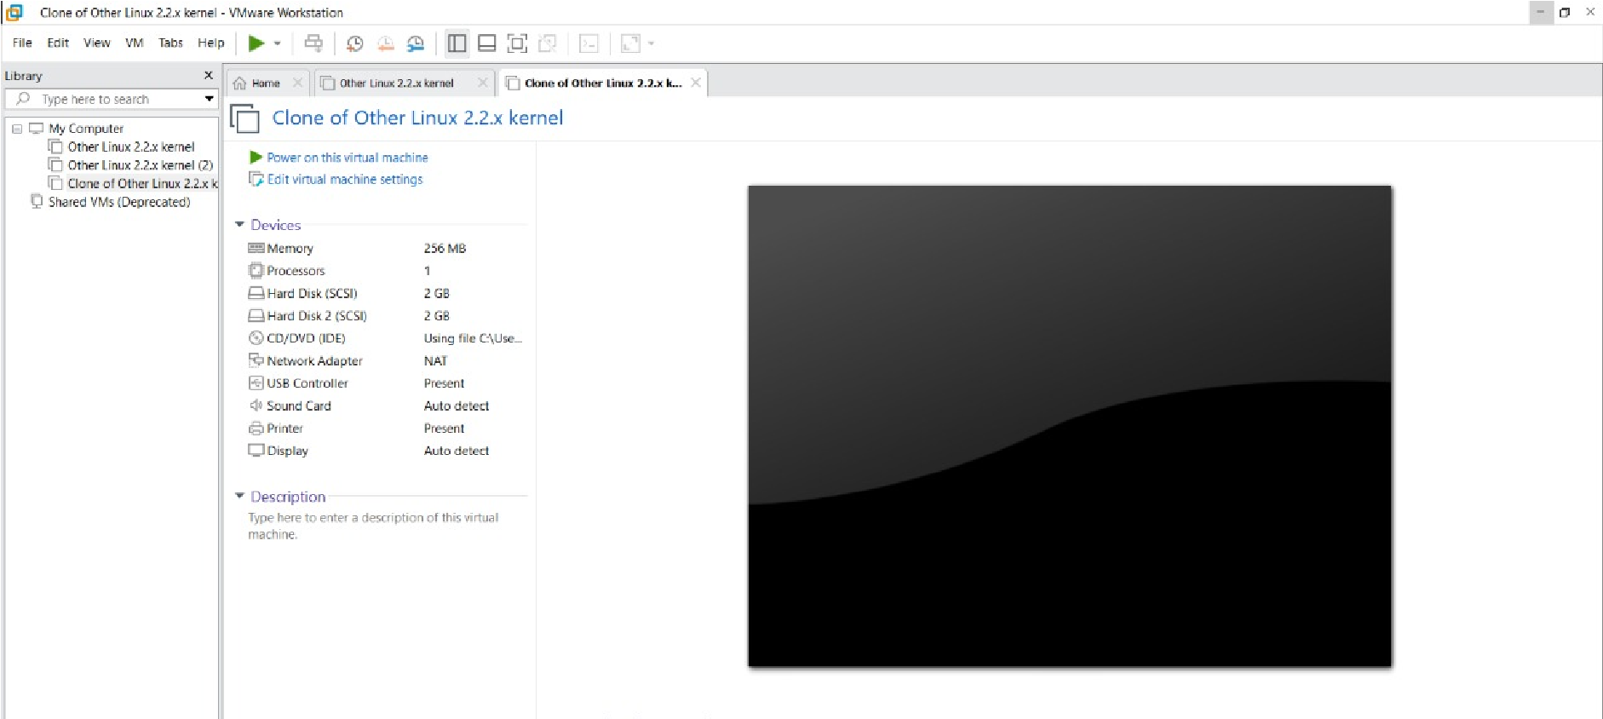

**STEP2: RIGHT CLICK THE VM AND GOTO THE SETTINGS**

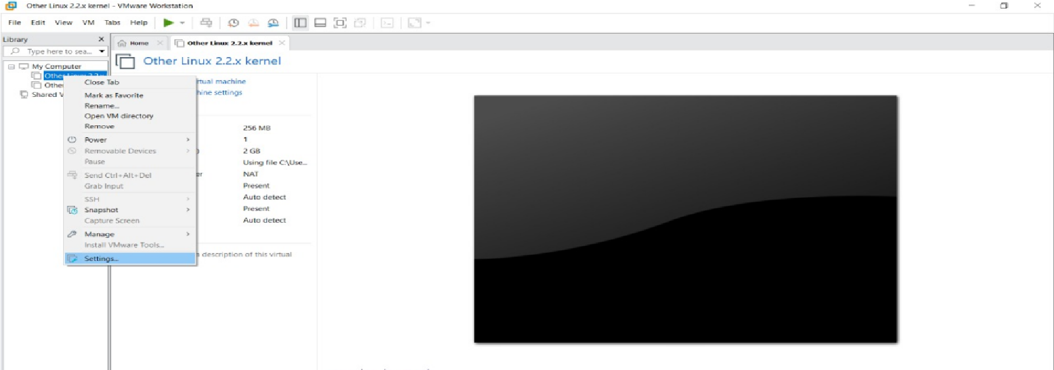

**STEP 3: ADD HARDWARE WIZARD AND SELECT SCSI AND CLICK NEXT**

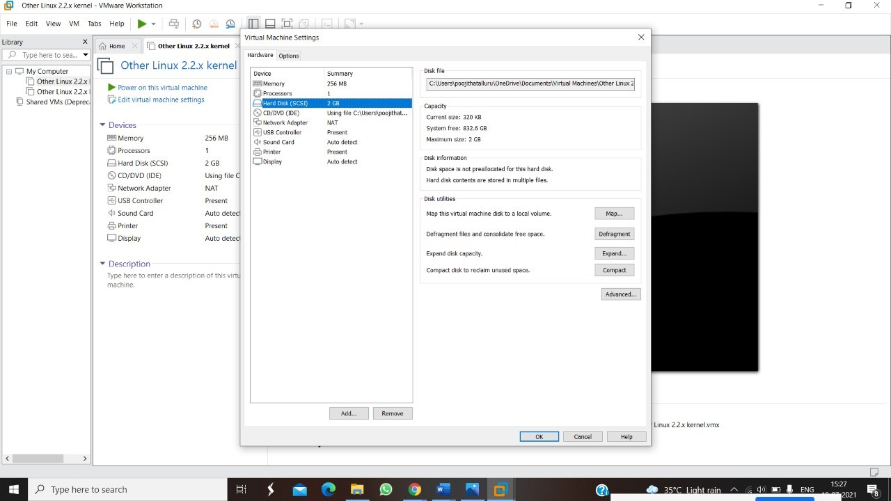

**STEP 4: CREATE NEW VIRTUAL DISK**

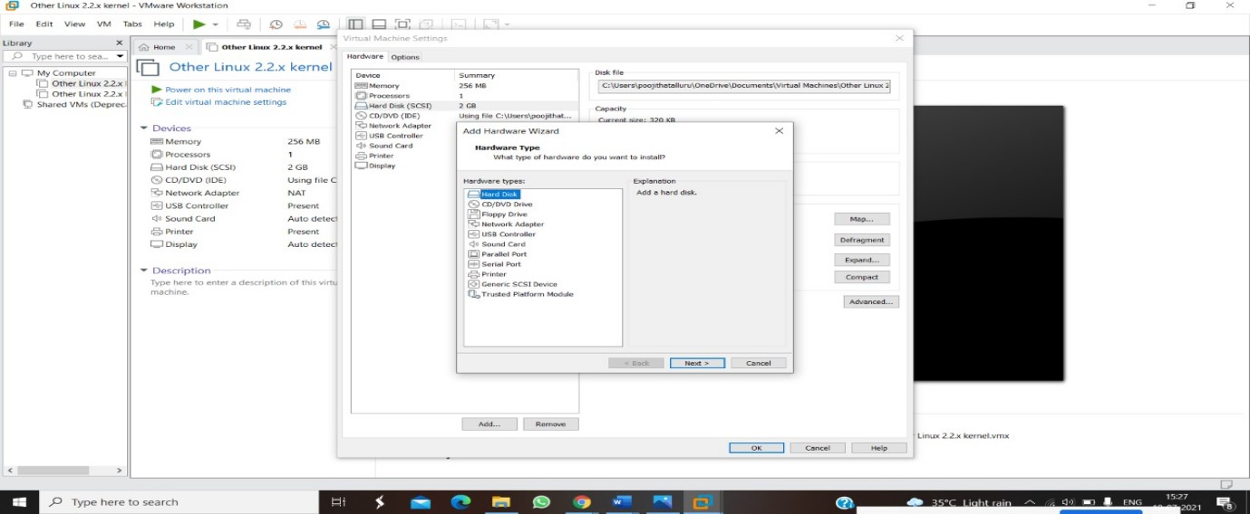

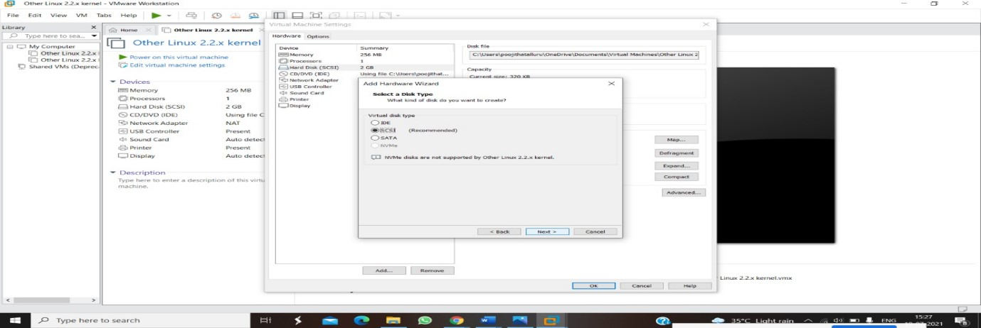

**STEP 5: SELCT THE DISK SIZE AS 2.0. AND SELCT SPLIT VIRTUAL DISK INTO MULTIFILES.**

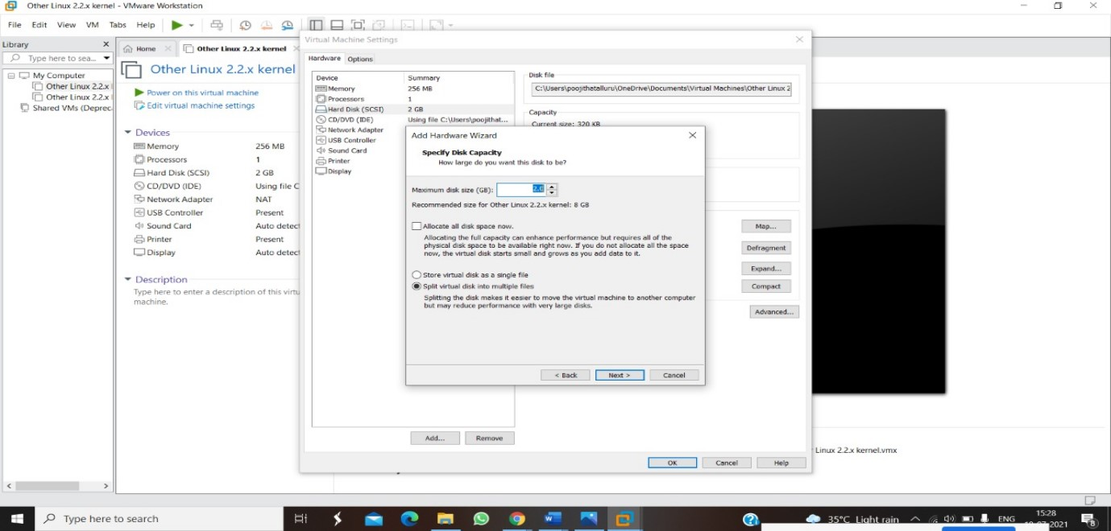

**STEP 6: GIVE NAME AND CLICK THE FINISH**

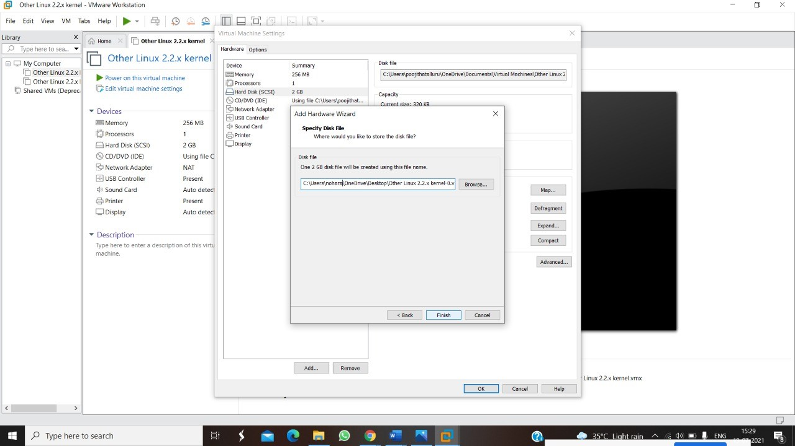

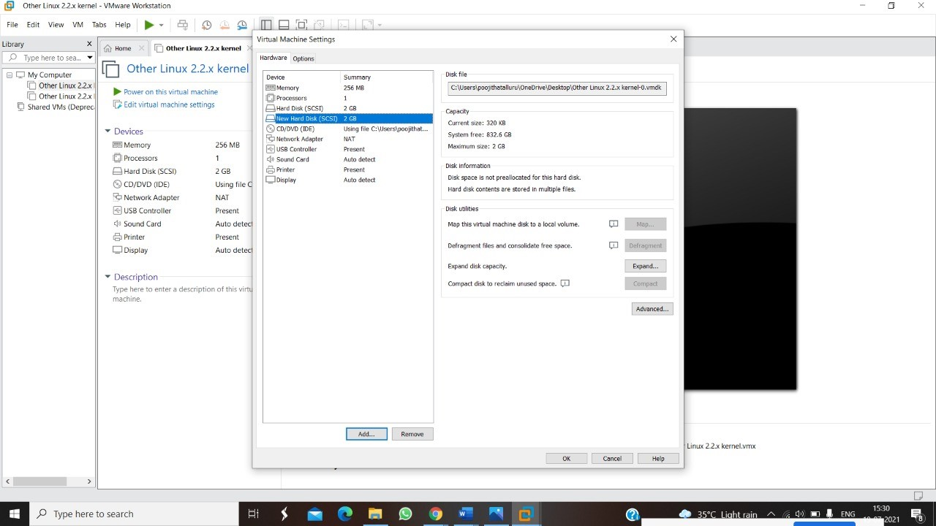

**RESULT:**